Problem Statement 5: Incrementally load data from Azure SQL Database to Azure Blob storage using the Azure portal:

* I prepared a data store to store the watermark value in a SQL database.
* I created a pipeline with the following workflow:
* I created two Lookup activities. The first Lookup activity is to retrieve the last watermark value. The second Lookup activity is to retrieve the new watermark value which are to be passed to the Copy activity.
* I created a Copy activity that copies rows from the source data store with the value of the watermark column greater than the old watermark value and less than the new watermark value. Then, it copies the delta data from the source data store to Blob storage as a new file.
* I create a StoredProcedure activity that updates the watermark value for the pipeline that runs next time
* I had some errors while creating the SourceDataset as I did not check the “First row only box” in order to select the maximum value of “LastModifytime” from the data source table. I had to go back and check the “First row only box”.
* 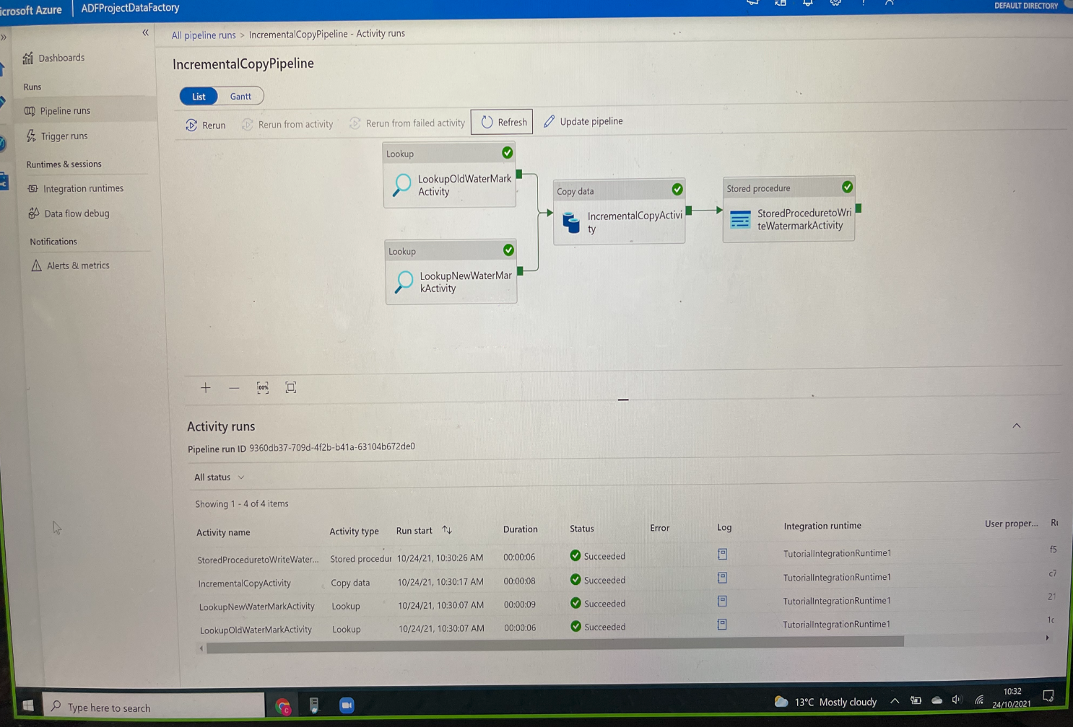

Figure 1: Succeeded pipeline runs